

**C.I.T.L. EXPERIMENT 1**

**Submitted By:**

|  |  |
| --- | --- |
| Akash Panicker | 2021300089 |
| Mahesh Patil | 2021300095 |
| Rohit Phalke | 2021300100 |
| Adwait Purao | 2021300101 |

**Submitted To:**

Prof. Sunil Ghane

**Inventory Management System**

**Aim:**

To use the Figma tool to make wireframes for the website of inventory management systems.

**Problem Statement:**

Develop an inventory management system for a retail store that efficiently tracks and manages the inventory of products. The system should provide real-time updates on stock levels, generate alerts for low stock items, enable easy addition and removal of products, and offer insights into sales trends to optimize restocking decisions.

**Tools used:**

* Figma

**Why Tools:**

**Figma** is a cloud-based design tool that is used by designers, developers, and product managers to create, edit, and share designs. It is used in the planning of projects and for making design before actual development of a site for a number of reasons:

* **Collaboration:**

Figma is a real-time collaboration tool, which means that multiple people can work on the same design file at the same time. This makes it ideal for teams that are working on a project remotely. It also allows for feedback to be given and incorporated quickly and easily.

* **Version control:**

Figma automatically tracks every change that is made to a design file. This means that it is easy to go back to a previous version of the design if needed. This is also helpful for tracking the progress of a project and seeing how the design has evolved over time.

* **Prototyping:**

Figma allows users to create interactive prototypes of their designs. This allows them to test the user experience and make changes before the design is actually developed. This can help to save time and money in the long run.

* **Flexibility:**

Figma is a very flexible tool that can be used to create a wide variety of designs, from websites and apps to logos and illustrations. This makes it a good choice for teams that are working on a variety of different projects.

* **Ease of use:**

Figma is a relatively easy-to-use tool, even for people who are not experienced with design software. This makes it a good choice for teams that are made up of people with different skill levels.

Overall, Figma is a powerful and versatile tool that can be used to improve the efficiency and effectiveness of project planning and design.

Here are some specific examples of how Figma can be used in the planning of projects and for making design before actual development of a site:

* **Creating user flows and wireframes:**

Figma can be used to create user flows and wireframes to visualize the user experience of a website or app. This can help to identify any potential problems with the design early on and make changes before development begins.

* **Creating mockups:**

Figma can be used to create high-fidelity mockups of a website or app. This can give stakeholders a realistic idea of what the finished product will look like and help to ensure that everyone is on the same page.

* **Creating prototypes:**

Figma can be used to create interactive prototypes of a website or app. This can help to test the usability of the design and get feedback from stakeholders before development begins.

* **Creating design systems:**

Figma can be used to create and manage design systems. This can help to ensure that all of the designs for a website or app are consistent and cohesive.

Overall, Figma is a valuable tool for project planning and design because it allows teams to collaborate easily, track changes to designs, create prototypes, and manage design systems.

**Link:**

<https://www.figma.com/file/iA8tQXVkaeoUUn1xmtRGU2/Inventory-Management-System-Project-CITL?type=design&node-id=0%3A1&mode=design&t=q232TLCh25vlV0qy-1>

**Slides with their description:**

**Fig 1 : Register Page**

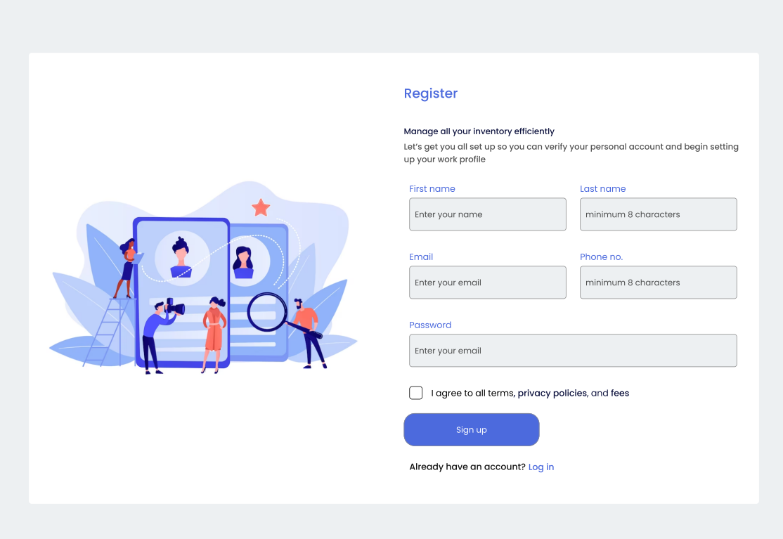

Theory:

* User visits the website and lands on the Register page.
* They provide their personal details, including name, email, and password.
* After submitting the registration form, the system validates the data, checks for duplicate emails, and creates a new user account if everything is in order.
* The user receives a confirmation email (if required) and is redirected to the Login page.

Flow:

After the user Registers successfully, he will be directed to the Sign In page to Login.

**Fig 2 : Login page**

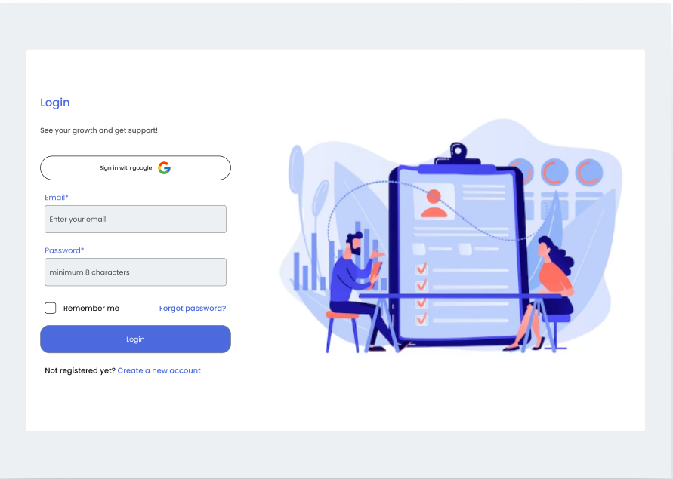

Theory:

* The user enters their registered email and password.
* The system verifies the credentials against the database.
* If the login is successful, the user is redirected to the Dashboard page; otherwise, they receive an error message and stay on the same page.

Flow:

If the user successfully logs in, he will be directed to the Dashboard Page.

If the user does not have an account he will be directed to the Registration Page.

**Fig 3 : Dashboard**

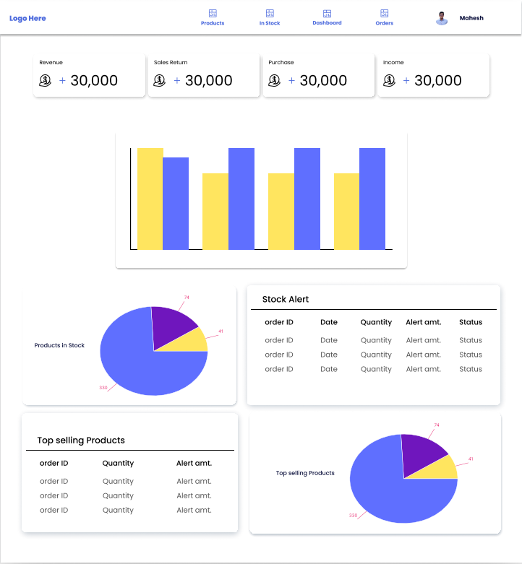

Theory:

* The Dashboard serves as the central hub for the user.
* It displays key information like current stock levels, sales trends, alerts for low stock items, and important notifications.
* Users can navigate to other sections from here, such as Stock Management and Analysis.

Flow:

The User can navigate through to Pages like the products page, orders page, his profile and others.

**Fig 4 : Products Page**

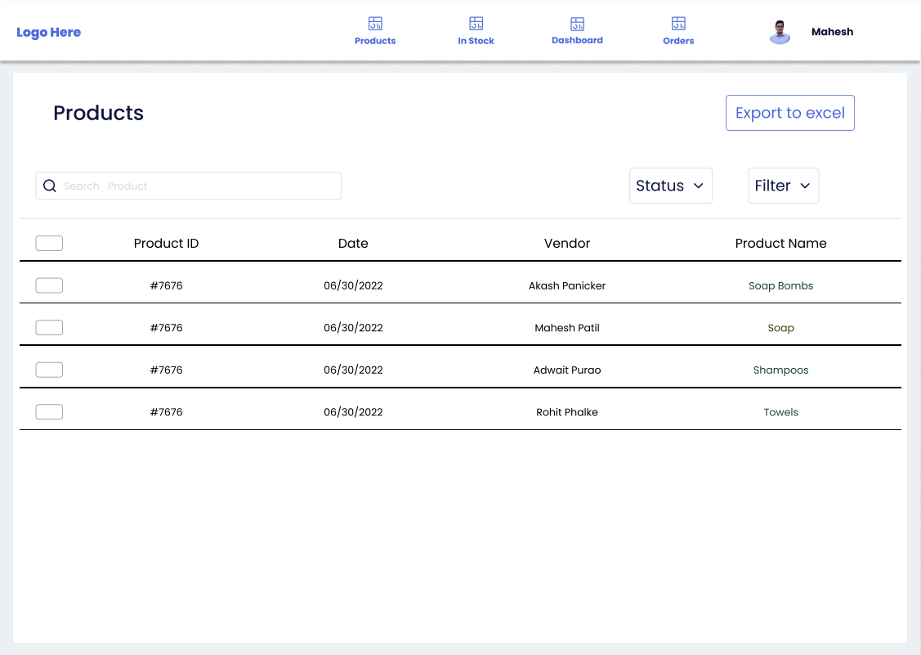

Theory:

* Users can access this page from the Dashboard.
* Users can view all his products here and get the option to filter the products according to name, date, vendor, etc.
* Also the data can be exported to excel sheet.

Flow:

The user can export as excel and open the corresponding downloaded excel sheet.

**Fig 5 : Stock Status Page**

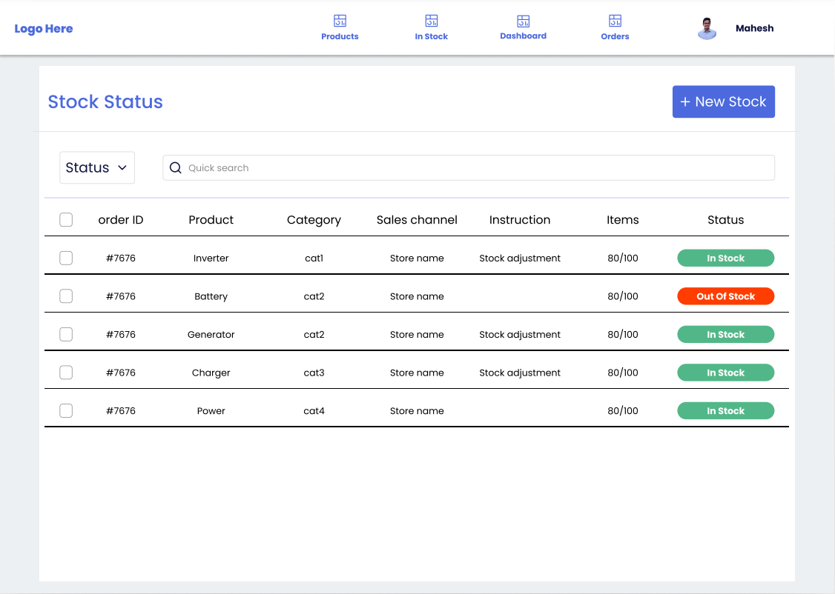

Theory:

* Here, they can perform various inventory-related tasks:
  + Add new products to the inventory by providing details like name, category, price, and quantity.
  + View the list of existing products, including their details.
  + Update product information or delete products when necessary.
  + Receive new stock shipments and update the inventory quantities.
  + Set reorder points and receive alerts for low-stock items.
  + Users can perform actions like searching for products, sorting, and filtering based on different criteria.

Flow:

Users can click the new page button to go to the add stock page.

**Fig 6 : Orders Page**  
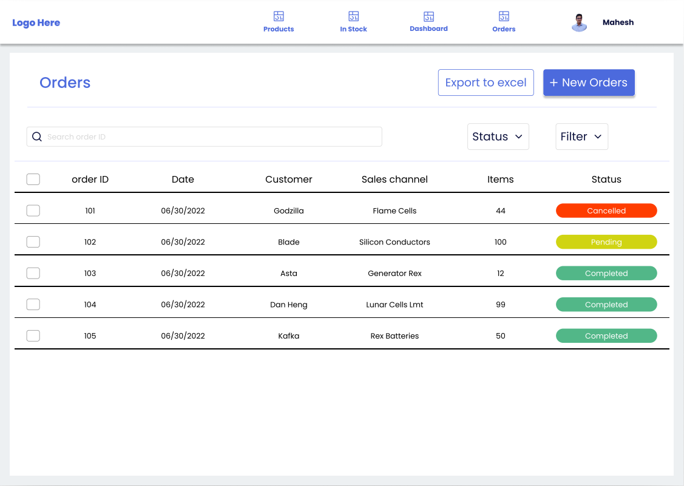

Theory:

Here, the user can view the status of the stocks in inventory which he requested from the vendors, like ‘completed’ indicates that the order is delivered successfully, ‘pending’ indicates that the order is yet to be delivered and ‘canceled’ indicates that the requested vendor has canceled the order.

Flow:

The user can export as excel and open the corresponding downloaded excel sheet.

The user can click on the new orders button to go to the Add new orders page.

**Our Learning Experience with Figma in Collaborative UI/UX Design**

In our collaborative effort to design an inventory management website for our CITL project, Figma played a central role in our learning journey. This versatile tool not only supported our creative process but also fostered effective teamwork. In this section, we outline the key lessons we gained, spanning collaborative design practices, responsive design, and user-centered principles. These insights were instrumental in shaping our understanding of UI/UX design and influenced the development of our website.

* **Collaborative Design:** We learned the importance of collaborative design using Figma, as it allowed us to work together in real time. This helped us streamline communication within our team and maintain design consistency throughout the project.
* **Responsive Design:** Our team grasped the significance of responsive design through Figma. We discovered how to create a user-friendly interface that adapts seamlessly to various screen sizes, ensuring a consistent user experience across different devices.
* **Interactive Prototyping**: We honed our skills in interactive prototyping with Figma. This was instrumental in our user testing efforts, enabling us to collect valuable feedback and iterate on our design to improve its usability and functionality.
* **Iterative Design Process:** Figma facilitated an iterative design process, which emphasized the iterative nature of UI/UX design. Our team learned the value of continually refining our designs based on feedback and user testing, leading to a more polished end product.
* **Teamwork:** Working in a team of four on Figma underscored the importance of effective teamwork in design projects. We realized how collaborating on a common platform enhanced our productivity and allowed us to capitalize on each team member's strengths.
* **User-Centered Design Principles:** Our experience with Figma reinforced the significance of user-centered design principles. We focused on designing with the end-users in mind, prioritizing their needs, preferences, and expectations throughout the design process.

**References:**

1. **Free Code Camp - Figma Tutorial:** <https://youtu.be/jwCmIBJ8Jtc?feature=shared>
2. **Snippets references**: <https://www.freecodecamp.org/news/figma-crash-course/>
3. **Color Theory :** <https://www.figma.com/community/file/909144554245974933/Color-Theory-for-UX-designers>

**Conclusion:**

Our journey in designing an inventory management system using Figma has been a transformative learning experience. The collaborative features of Figma have proven to be invaluable, enabling us to work cohesively as a team while maintaining design consistency.

This endeavor has highlighted the importance of teamwork and reaffirmed our dedication to a user-centered design approach.

In essence, our project, driven by the powerful capabilities of Figma, has not only honed our design skills but also fostered effective collaboration. It has instilled in us a deeper appreciation for user-centric principles.

As we forge ahead, the insights gained from this project will continue to illuminate our path in UI/UX design. They will ensure that our future endeavors are successful and user-focused, thereby elevating the quality of our solutions and enriching the user experience.